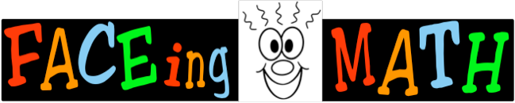
Colour the face that shows how you feel about each thing.
 | I like math class.
 | I like solving problems that are hard.
 | I like working with a partner in math class.
 | I like working with a group in math class.
 | Math is fun.
 | I like helping other people in math.
 | I like learning new things in math.
 | I like using manipulatives in math.
 | I like drawing pictures to solve problems.
 | I like writing about math.
 | I like doing math on the computer or IPAD.
 | I like answering questions in math time.
 | I am good at math.

