Grade 2 Summative Assessment Area and Grids
Knowledge and Understanding
What is the area of the shaded shape?
Square units ______ Square units _____

On the grid draw 2 shapes with an area of 8 square units.
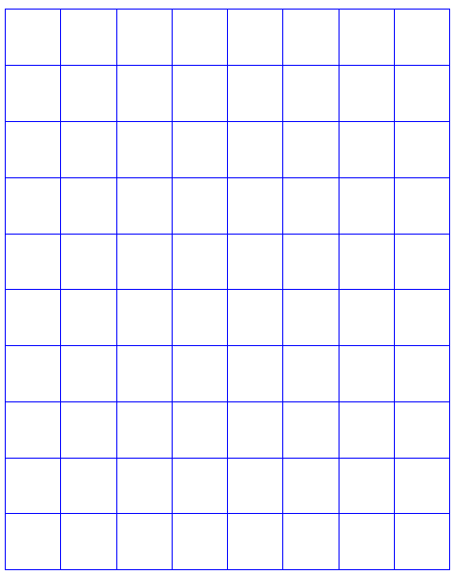

 |  |  |  | Grandma’s House
 | 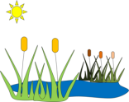


  Red Riding Hood’s House |  |  |  | 
 |  |  |  |  | 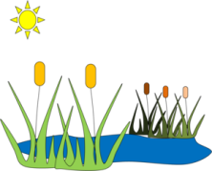
Communication
Can you describe 2 ways to get from Little Red Riding Hood’s house to Grandma’s cottage?
N
W E
S

Thinking
Judy thinks that the picture of the horse has the same area as the frame. Is she right? Explain your thinking.

Categories | Level 4 (A) | Level 3 (B) | Level 2 (C) | Level 1 (D)
Knowledge and Understanding | Demonstrates an in depth understanding of area by accurately completing 4 of the area questions | Demonstrates considerable understanding area by accurately completing 3 of the area questions | Demonstrates some understanding of area by accurately completing 2 of the area questions | Demonstrates limited understanding of area by accurately completing 1 of the area questions
Thinking | Choses efficient strategies to solve the problem,  Carries strategies through in a highly organized manner to an accurate solution | Choses appropriate strategies to solve problem,  Carries most strategies through in a generally organized manner usually arriving at accurate solutions | Attempts to solve problem by  carry some strategies through in a somewhat organized way sometimes arriving at an accurate solution | Models a small part of the problem but rarely carries it through to a solution  Process is hard to understand or follow
Communication | Explains path chosen clearly and completing using math vocabulary  Communicates clearly process used in (pictures, numbers and words) | Explains path chosen generally clearly and completely using some math vocabulary  Generally communicates process used | Explains path chosen somewhat completely using few mathematical terms  Simply in a somewhat clear way communicates process used | Explains path chosen unclearly in very limited ways  Communicates process in a disorganized or incomplete way

