Money Assessment Grade 1
I can tell the names and values of coins.
Coin names: dime loonie nickel toonie quarter
Coin | Name | Amount
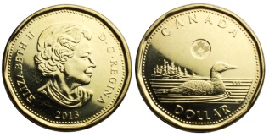

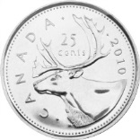
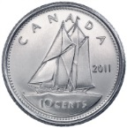
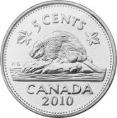
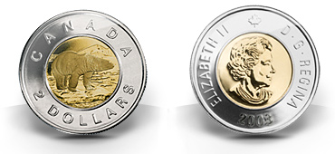
names and values of coins.
I can make the same amount of money in different ways.
Make 20¢ in 4 different ways.
Category | Level 1 | Level 2 |  | Level 3 | Level 4
Knowledge and Understanding | Accurately identifies few coins: names/ amounts (1/2) | Accurately identifies some coins: names/amounts (3/4/5) |  | Accurately identifies most coins: names/ amounts (6/7/8) | Accurately identifies all or almost all coins; names and amounts
Thinking | Accurately shows money in 1 way | Accurately shows money om 2 ways |  | Accurately shows money amount in 3 ways | Accurately shows money amount in 4 ways

