Grade 2 Geometry Formative Assessment
- Match each shape to its name.
sphere cone cube rectangular prism pyramid cylinder

- Match the net to its shape

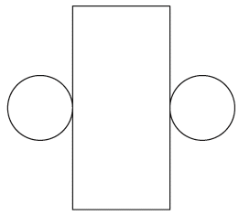


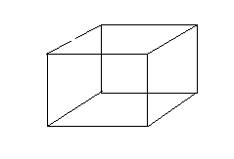
- How many vertices does this shape have? _________________
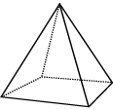

How many faces does this shape have?____________________

- Use the shapes in one of the buckets. Sort them in a way that makes sense to you. Tell your teacher how you sorted them.
___________________________________________________________________________________________________________________________________________________________________________________________________________________________________________________________________________________________________________________

Gr. 2 Geometry Formative Data
√+ very good √ good √- some L - limited

Student | Names | Nets | Vertices/Faces | Sorting Attributes

Observations

