

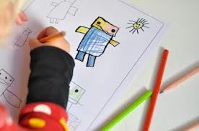

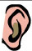
Give One Get One
- When you hear the word ‘___________’ what do you think about or picture?

- Fill in the top two (2) boxes with a picture or a word that shows your idea.

- Talk to your classmates about your ideas. Take an idea from each classmate to fill in the four (4) other boxes.

- Together we will fill in the bottom box.


www.etfoassessment.ca

