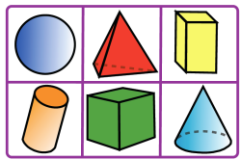
Grade 1 - 3D Assessment
Name | Look Fors: | Anecdotal Comments
- Identifies shapes
- Identifies faces
- Identifies edges
- Identifies vertices
- Identifies roll, stack, slide
- Gives real life examples

- Identifies shapes
- Identifies faces
- Identifies edges
- Identifies vertices
- Identifies roll, stack, slide
- Gives real life examples

- Identifies shapes
- Identifies faces
- Identifies edges
- Identifies vertices
- Identifies roll, stack, slide
- Gives real life examples
- Identifies shapes
- Identifies faces
- Identifies edges
- Identifies vertices
- Identifies roll, stack, slide
- Gives real life examples
- Identifies shapes
- Identifies faces
- Identifies edges
- Identifies vertices
- Identifies roll, stack, slide
- Gives real life examples
- Identifies shapes
- Identifies faces
- Identifies edges
- Identifies vertices
- Identifies roll, stack, slide
- Gives real life examples

