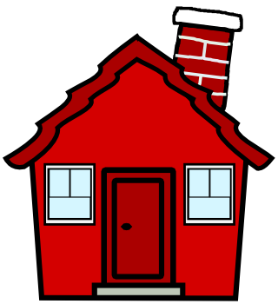

Fraction/Decimal Avenue

Congratulations you have just moved into Fraction/Decimal Ave. Use the following information to draw a map of your street!

- 1/10 of the houses are for sale
- There are trees in front of .20 of the houses
- .4 of the houses have a dog outside
- 3/10 of the houses have a red door
- .6 of the houses have blue roofs
- 8/10 of the houses have two large front windows
- There are cars parked in 3/5 of the driveways.
- .5 of the house have flowers in the front

Categories | Level 1 | Level 2 | Level 3 | Level 4
Knowledge and Understanding | With several errors map reflects fraction and decimal amounts (1-2) | With some errors map reflects fraction and decimal amounts  (3-5) | With few minor errors map reflects fraction and decimal amounts (6-7) | Map accurately reflects fraction and decimal amounts

