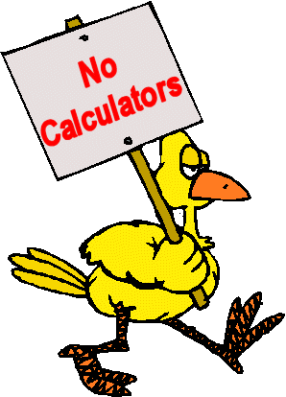
Pretest Addition and Subtraction Do not use a calculator!
Calculate the sum or difference for the questions below.
46 + 18 75 – 26 999 + 1786
386 – 248 1045 + 434 1008 – 165

Which sum is greater that 1000? Use estimation do not use the calculation!
528 + 489 428 + 574 136 + 852
Explain how you estimated?

Which differences are between 400 and 500? Do not do the calculation estimate! Circle them. Explain your thinking.
871- 422 615-234 827-539

Newburgh, Centreville and Tamworth schools would like to go to the musical production of Snowflake in Kingston. The theatre has 700 seats at each performance. Can all three school go to the same performance? Use your problem solving placemat and show all your work.
School | # of students
Newburgh | 236
Centreville | 188
Tamworth | 364

Formative Data Addition and Subtraction
Skill |   Got It! | 
Addition with Regrouping

Subtraction with Regrouping
Estimation Addition
Estimation Subtraction
Multi digit Addition


