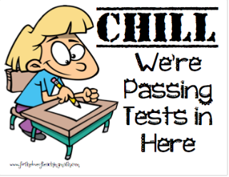
My Math Assessment Self Assessment
Take a look at the different questions beside each question number on the grid put a check mark in the appropriate column if you had it: right, partially right or wrong. Put a check mark in the column that reflects why you had it wrong; Simple or careless mistake, I need help.
Question # | Right | Partly Right | Wrong | Simple/Careless Mistake | I need help!
1
2
3
4
5
6
7
8
9
10
11
12
13
14

Highlight your next step!
Based on this review of my test to get better next time I need to:
Do some extra practice and meet with my teacher before a test
Do a better job listening and participating during math lessons so I am sure I understand.
As for help when I don’t understand.
Do my math homework every night.
Check my work over carefully to make sure I didn’t make careless mistakes.
Explain my thinking with more detail and an example.
Review my math vocabulary so I can use it when I explain my thinking.
Organize my process of solving questions better so they are easier to follow.
Copy down and review models when I am given them.

