

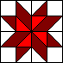

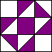

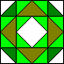



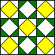

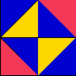

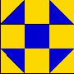
Task
You are to design a quilt pattern using any combination of shapes and colours. Your pattern must include at least 3 colours. Plan your design out first on newsprint.
Chose any number of 4 x4 coloured squares and cut them to different fractional shapes to make your quilt. Paste your design on the 12x12 block. When your quilt piece is done, on a separate sheet of paper, calculate the fraction of the whole shape each colour covers. Do an addition and subtraction question for any two colours. Make sure all your work is neat and organized.

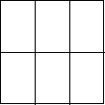
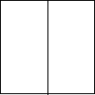
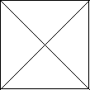
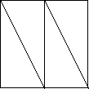
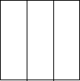
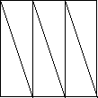

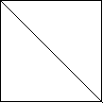
1/4 1/3 1/6

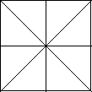
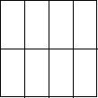
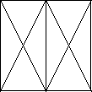
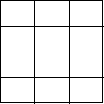
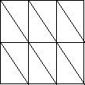
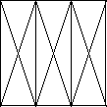

Mathematics assessment rubric
Categories | Level 1 | Level 2 | Level 3 | Level 4
Knowledge and Understanding  facts, terms, procedural skills | With several major errors completes addition, subtraction and fractions of total shape for each colour | With several minor errors or omissions completes addition, subtraction and fractions of total shape for each colour | With few minor errors or omissions completes addition, subtraction and fractions of total shape for each colour | With rarely any errors or omissions completes addition, subtraction and fractions of total shape for each colour
Thinking  understands the problem  makes a plan(chooses a strategy)  carries out the plan  looks back - justifying, proving, reflecting  use of critical/creative thinking processes | In a very limited way plans out quilt design  Uses one or two colours with few basic fraction pieces  uses critical/creative thinking processes with limited effectiveness to solve non routine problems or investigations | Simply with limited detail plans out quilt design  Use mostly 2 colours with some basic fraction pieces  uses critical/creative thinking processes with some effectiveness to solve non routine problems or investigations | Generally plans out quilt design making some adjustments  Uses 3 colours and a number of different fraction pieces  uses critical/creative thinking processes with considerable effectiveness to solve non routine problems or investigations | Plans out quilt design in detail adjusting as needed  Utilizes 3 colours, may have more, and a wide variety of fraction pieces  uses critical/creative thinking processes with high degree of effectiveness to solve non routine problems or investigations
Communication  expresses mathematical ideas orally , visually and in writing using numbers symbols, pictures | communicates mathematical process with little evidence of organization, clarity,  uses few conventions, to convey mathematical information | communicates mathematical process with some degree of organization, clarity,  uses some basic conventions, to convey basic mathematical information | communicates mathematical process with an appropriate degree of organization, clarity,  Usually uses conventions, to convey mathematical information | communicates mathematical process with a high degree of organization, clarity  Consistently uses conventions to convey mathematical information
Application  makes connections bwt. knowledge & skills to  transfer skills to solve real life applications | demonstrates the ability to make connections and transfer knowledge and skills to new contexts with limited effectiveness | demonstrates the ability to make connections and transfer knowledge and skills to new contexts with some effectiveness | demonstrates the ability to make connections and transfer knowledge and skills to new contexts with considerable effectiveness | demonstrates the ability to make effective connections and transfer of knowledge and skills to new contexts

